**GOS LEA BUSSÁ?**

*(Nuohtta: “Fader Jakob”)*

GOS LEA BUSSÁ?

GOS LEA BUSSÁ?

LEA GO BEAVDDI VUOLDE?

LEA GO BEAVDDI VUOLDE?

II DAT DIEPPE OIDNO.

II DAT DIEPPE OIDNO.

MU SÁLAS DAT LEA.

MU SÁLAS DAT LEA.





Bussá lea beavddi alde.

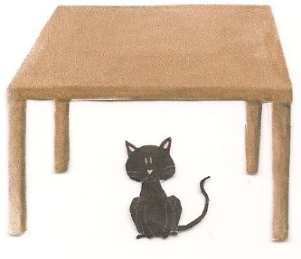

Bussá lea mu sálas.

Bussá lea beavddi vuolde.

Teaksta ja hábmen: Ellen Ravna, Sirpmá skuvla, Deanu gielda, 2017

Govat: <http://clipart-library.com/clipart/518108.htm>, <a href="https://www.clipartsgram.com/">clipartsgram.com</a>

<a href="https://www.clipartsgram.com/">clipartsgram.com</a>